L LOGO



**15 February 2025**

**Understanding Balvatika& the 3-Year Kindergarten Program as per**

**the National Education Policy (NEP) 2020**

**Dear Parents,**

**Greetings from Indian School Jalan**

**Balvatika is now an integral part of Kindergarten and falls under the structured Central Board of Secondary Education (CBSE) curriculum. It is designed to provide a strong foundation for early childhood education through a play-based, activity-driven approach, ensuring that children develop essential cognitive, social, and motor skills.**

**Many parents have a misconception that enrolling their child in the Balvatika program (3-year Kindergarten) results in a loss of one academic year.**

**However, this is not true. The National Education Policy (NEP) 2020 is structured to align with international best practices and mandates that every student completes 15 years of education in school.**

**Additionally, Balvatika is not optional and cannot be skipped. According to CBSE, India, the completion of three years of Kindergarten (Balvatika 1, 2, and 3) is mandatory for a child’s progression to Class 1.**

**Kindly review the detailed FAQs provided below for a more comprehensive understanding.**

**FAQ’s- Admission to Balvatika and Kindergarten**

1. **What is the National Education Policy (NEP) 2020?**

**The NEP 2020 envisages that the extant 10+2 structure in school education will be modified with a new pedagogical and curricular restructuring of 5+3+3+4 covering ages 3-18 as shown in the representative figure. As a result, 14 years of schooling has changed to 15 years.**

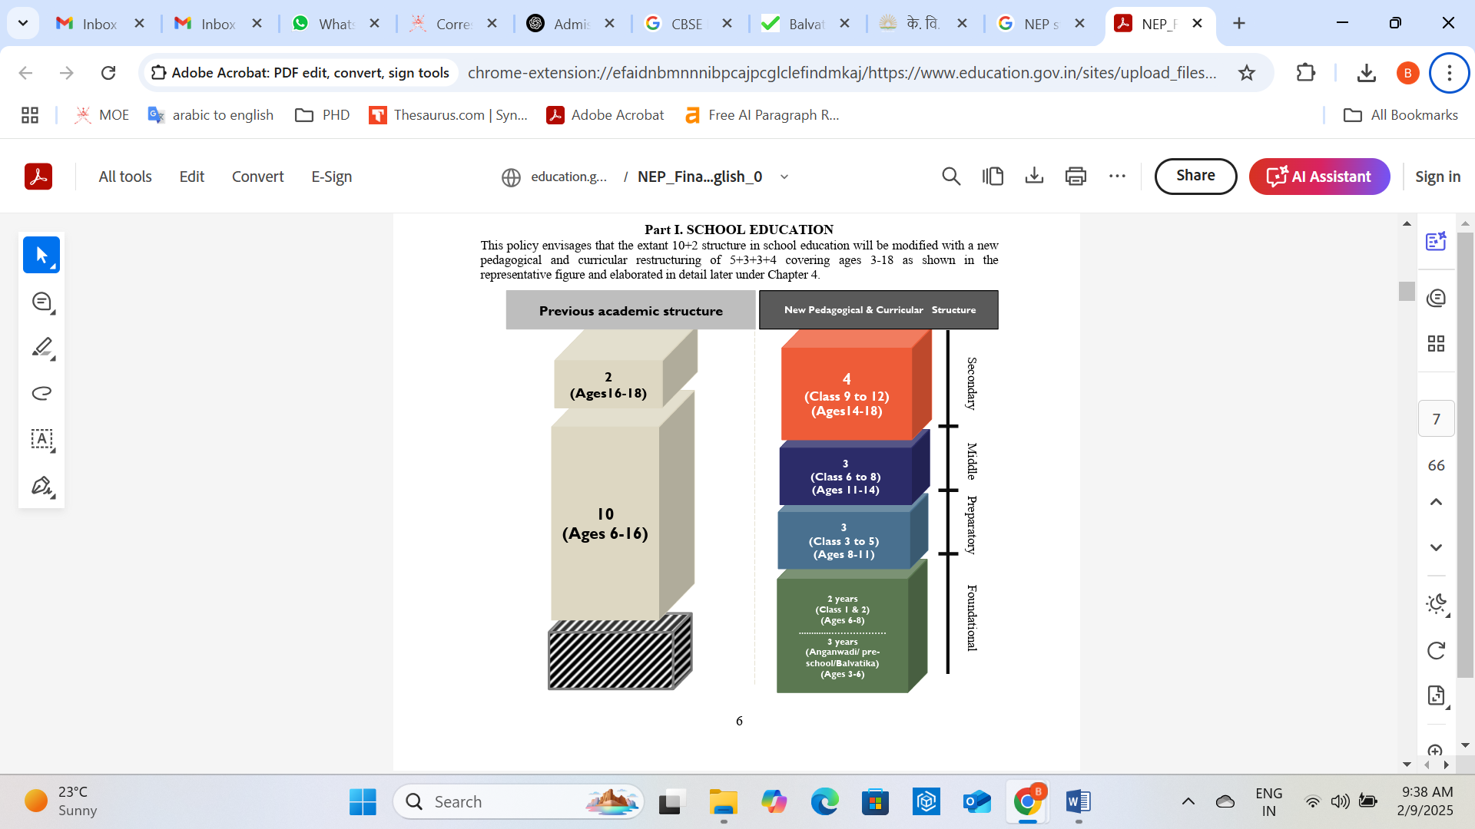

***Source:***[***https://www.education.gov.in/sites/upload_files/mhrd/files/NEP_Final_English_0.pdf***](https://www.education.gov.in/sites/upload_files/mhrd/files/NEP_Final_English_0.pdf)

1. **What is Balvatika, and why is it being introduced?**

As per the National Education Policy (NEP) of India, the Foundational Stage, will now include three years of Kindergarten (Balvatika) for children aged 3 to 6 years, followed by Classes 1 and 2 for ages 6 to 8 years.

**A significant shift for Indian Schools in Oman under the NEP is the expansion of the kindergarten program from the existing 2-year structure (KG I and KG II) to a 3-year program (Balvatika, KG I and KG II), ensuring a more comprehensive foundational education.**

Indian Schools Oman is set to implement ‘Balvatika’ (Pre-school) as a part of NEP 2020 with effect from the academic year 2025-2026, commencing from 1st April 2025.

1. **Will Balvatika be offered in all Indian Schools in Oman?**

Yes, Balvatika will be implemented in all Indian Schools in Oman following the Central Board of Secondary Education (CBSE) curriculum as part of the NEP 2020 with effect from academic year 2025-2026.

1. **What is the age for admission in Balvatika, KG I, KG II and class I?**

As per the National Education Policy of India (NEP 2020), children must meet the following age criteria as of **March 31, 2025**:

* **Balvatika**: Completed 3 years (as of 31 March 2025)
* **KG I**: Completed 4 years (as of 31 March 2025)
* **KG II**: Completed 5 years (as of 31 March 2025)
* **Class I**: Completed 6 years (as of 31 March 2025)

1. **Can children below 3 years of age (as of 31st March 2025) apply for admission to Balvatika?**

No, children who have not completed 3 years of age by 31st March 2025 do not qualify for admission to Balvatika for the 2025-2026 academic year.

1. **My child is above 3 years of age and has completed pre-kindergarten from a recognized school in India/Oman. Is my child be eligible for admission to KG 1 for the academic year 2025-2026?**

If your child is above 3 years of age and has completed pre-kindergarten and has a valid Transfer Certificate (TC) from a recognized school in India or Oman, the child will be eligible for admission to KG I, irrespective of the revised age criteria for the academic year 2025-2026.

The promotion policy recognizes the completion of a prior grade as proof of eligibility and will remain consistent from Pre-KG to KG I to KG II, and KG II to Class I respectively.

1. **Will children who have not completed Balvatika be eligible for KG I admission?**

Yes. Children can directly enter KG I if they meet the age requirement (4 years but not 5 years as of March 31, 2025). **Balvatika is not mandatory for admission to KG I for academic year 2025-2026.**

1. **My child has completed KG I in another Indian school in India/Oman but does not meet the age requirement for KG II as per the new age criteria. Will my child still be eligible for KG II admission?**

If your child has completed KG I and has a valid Transfer Certificate (TC) from a recognized school in India or Oman, the child will be eligible for admission to KG II, irrespective of the revised age criteria. The promotion policy recognizes the completion of a prior grade as proof of eligibility and will remain consistent from KG I to KG II, and KG II to Class I respectively.

1. **My child has completed KG II in another Indian school in India/Oman but does not meet the age requirement for Class I as per the new age criteria. Will my child still be eligible for Class I admission?**

If your child has completed KG II and has a valid Transfer Certificate (TC) from a recognized school in India or Oman, the child will be eligible for admission to Class I, irrespective of the revised age criteria. The promotion policy recognizes the completion of a prior grade as proof of eligibility and will remain consistent from KG I to KG II, and KG II to Class I respectively.

**10. My child has not undergone prior schooling (in a recognized institution) and I am seeking new admission to Indian Schools. Will my child be admitted to a class based on the age wise criteria?**

If a student has no prior schooling from a recognized institution, admission will be granted based on the age criteria. However, this is only applicable for admissions upto Class 1. For higher classes, a Transfer Certificate (TC) from a recognized institution is necessary, and admission will depend on the successful completion of the previous grade, irrespective of age.

**Key Clarifications for Parents**  
✅**Globally Aligned** – Matches best practices in early education worldwide.  
✅**Better Readiness** – The **3-year Kindergarten** model helps in **strong cognitive, social, and emotional development**.  
✅**Uniform Progression** – Children move seamlessly from **Balvatika 1 → KG 1 → KG 2 → Class 1**.

**Key Clarifications for Schools**

**Admissions to Balvatika 2025-2026**

1. Minimum age criteria to be met – 3 years completed as of 31 March 2025.

**KG I admissions 2025-2026**

1. Minimum age criteria to be met – 4 years completed as of 31 March 2025.
2. TC is accepted for KG I if the child has completed **“pre-kindergarten**” from any recognized school in India or Oman.
3. In case child has not gone to any school, the admission is subject to meeting the above age criteria and evaluation by the Principal and deemed fit for direct admission to KG 1.

**KG II admissions 2025-2026**

1. Minimum age criteria to be met – 5 years completed as of 31 March 2025.
2. TC is accepted if they completed KG I from any recognized school in India or Oman
3. In case child has not gone to any school , the admission is subject to meeting the above age criteria and evaluation by the Principal and deemed fit for direct admission to KG II.

**Class I admissions 2025-2026**

1. Minimum age criteria to be met – 6 years completed as of 31 March 2025. (direct admission)
2. TC is accepted if they completed KG II from any recognized school in India or Oman (including private nurseries)
3. In case child has not gone to any school , the admission is subject to meeting the above age criteria and evaluation by the Principal and deemed fit for direct admission to Class I.

**The above guidelines apply specifically to admissions for the academic year 2025-2026 and do not guarantee applicability in future years.**

We encourage parents to embrace this structured approach, ensuring a smooth academic journey for your child.

For more details, please visit [www.indianschoolsinoman.com](http://www.indianschoolsinoman.com)

Parents seeking additional clarification may contact the admissions department of the respective schools for further information.

Best Wishes,